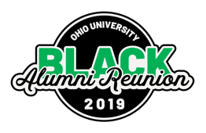
2019 BAR Communication/Marketing Timeline: SEPT 12-15, 2019
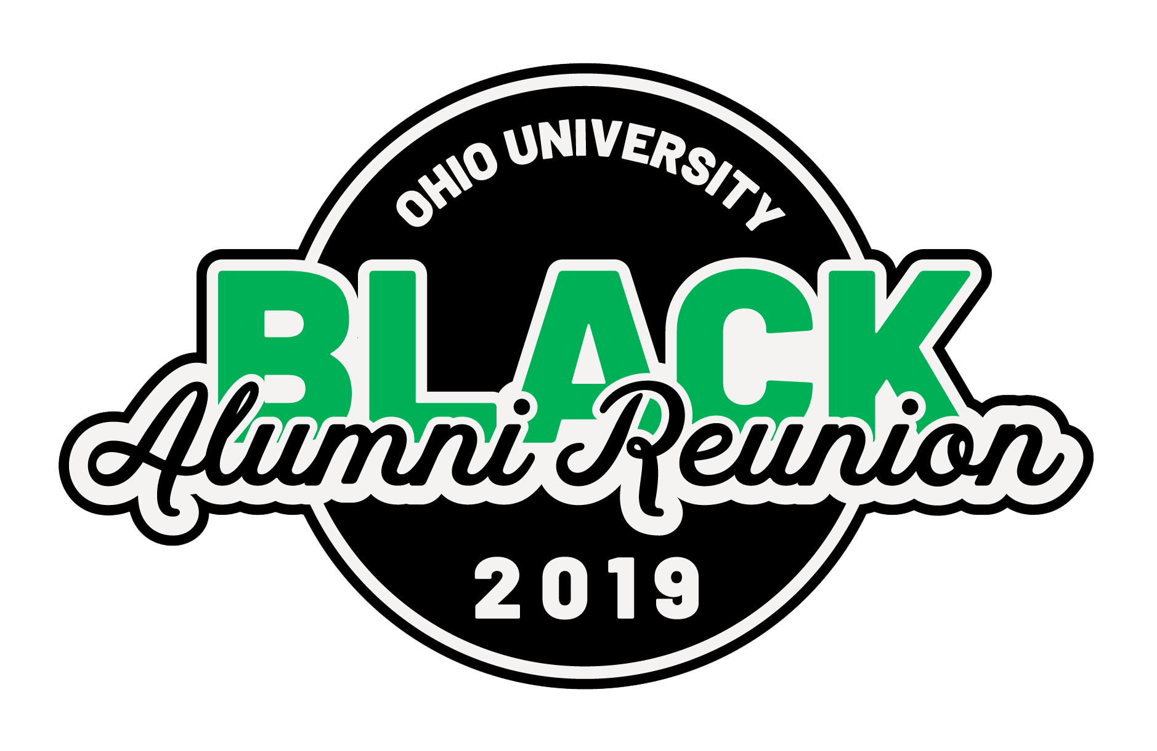
Emails: Date Requested Production Date 2022 Production Date
Official SVD email | 5/8 | 5/30 | 2/15/2022
Official Invitation email | 7/18 | 8/14 | 7/15/2022
Get excited for BAR email | 8/10 | 8/20 | 08/1/2022
See you soon! | 9/01 | 9/10 | 09/01/2022
Video from Nellis |  | 9/11

Print Date Requested Production Date 2022 Production Date
EBN Urban Scholars Thank You Post Card | 8/1 | 9/6 | n/a
Transportation Car Magnet | 8/12 | 9/6 | 8/30/2022
Conversational Table Tent | N/A | CANCELLED
Golf Cart Banners | N/A | CANCELLED
Official SVD Postcard | 5/13 | CANCELLED—couldn’t identify audience list in time | 2/1/2022
Memento with registration (Pop Socket) | 5/17 | 8/2
SWAG bags (giveaway) | 6/15 | 8/2 | 8/2/2022
Print Invitation | 6/14 | 09/1 | 6/15/2022
Swag Items | 7/2 | 9/6 | 8/15/2022
T-Shirt through BS | 7/5 | 8/15 | 8/1/2022
Bobcat Store Coffee Stickers | 7/12 | CANCELLED—didn’t reserve space at Front Room | 8/15/2022
2019 Gala Program | 7/15 | 9/4 | 8/25/2022
Annual Giving Appeal, Direct Mail | 7/18 | CANCELLED
Tabloid Guide | 7/31 | 9/2 | 8/25/2022
Memorial Wall Banner, Installation | 7/31 | 9/6 | 8/25/2022
EBN Meeting Program | 8/6 | 9/6 | 8/25/2022
Gala Table #s | 8/7 | 9/6 | 8/25/2022
Transportation Easel + Posters | 8/7 | 9/6 | 8/25/2022
Directional Yard Signs | 8/7 | 9/6 | 8/25/2022
Banners | 8/8 | 9/6 | 8/25/2022
Decade Photo Signs | 8/8 | 9/6 | 8/25/2022
Easel Signs (indoor) | 8/8 | 9/6 | 8/25/2022

Social Media Date Requested Production Date 2022 Production Date
BAR Event Coverage |  | On Going
BAR Promotion |  | On Going
BAR preliminary schedule (FB) |  | 4/15
BAR registration live! (FB) |  | 7/24
BAR calendar of events (FB) |  | 8/22
BAR live event coverage (IG) |  | 9/12 -9/15
BAR recap |  | 9/19
BAR gala coverage |  | 9/21

Multimedia Date Requested Production Date 2022 Production Date
BAR promo video | 5/9 | 8/18
Trail Blazers Award Video: William (Bill) Allen | 5/13 | 9/6
Trail Blazers Video: Alvin Adams | 5/13 | 9/6
Event Video/Photo Coverage | 7/17 | 9/12

Media/News Date Requested Production Date 2022 Production Date
OT News: Announcement |  | 2/20
OT News: Preliminary Schedule |  | 4/15
OT News: Registration Live |  | 6/26
OT News: Preview story |  | 8/19
OT News: Recap story |  | 9/19
OT News: Gala story |  | 9/19

Web Date Requested Production Date 2022 Production Date
BAR Web Banner on /alumni website |  | 7/13
BAR Webpage- info coming soon | N/A | 4/15
Jotform for Unofficial Events | 5/17 | 5/31
FAQ Pages – Update | N/A | 6/13
Luminate Registration Pages | N/A | 6/27

Digital Design Date Requested Production Date 2022 Production Date
Branding | 3/1 | 3/8/19
Email Headers | N/A | 6/6/19
Social Media Graphics | 7/2 | 7/15/19
Baker Slides (4 versions) | 7/17 | 8/16/19
OUAA/BS T-Shirt Slides | 8/15/2019 | 8/22/2019
Ohio.edu/Alumni Web Banner | 3/5 | 3/15
Gala Power Point Slides + Script | 8/8 | 9/6

